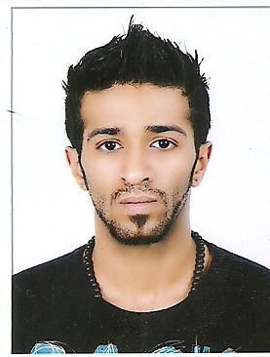 CURRICULUM VITE

Personal Information

Name Ebrahim Kahlil Ebrahim Alshuwaikh

Date of birth 15\11\1988

Nationality Bahraini

CPR Num 881105376

Address R:1031 H:1991 Hamad Town 1210

Contacts No 35545181 & 36305757

Qualification and Skills

Qualification Secondary school certificate

Personal Skills Communication

Experience

Experience 1. Salesman and superviser in Bahrain Duty free

2. Salesman in BENCH & THM in Bahrain mall

3. Collection & Follow up supervisor in eliet car rental

4.Reception Department-24 hours clinic in Al kindi specialised hospital

Launguage

Launguage Arabic

English

Thai

Tagalo